Question 1
- The crabs dataset is a data frame with 200 observations. This data describes 5 morphological measurements on 50 crabs each of two colour forms and both sexes, of the species Leptograpsus and variegatus collected at Fremantle, W. Australia. The data contains 8 variables; species (factor with 2 levels), sex(factor with 2 levels), Index (integers), frontal lobe (mm), rear width(mm), carapace length (mm), carapace width (mm) and body depth (mm).

- R code

Output
library(MASS)
data(crabs)
str(crabs)
'data.frame': 200 obs. of 8 variables:
$ sp : Factor w/ 2 levels "B","O": 1 1 1 1 1 1 1 1 1 1 ...
$ sex : Factor w/ 2 levels "F","M": 2 2 2 2 2 2 2 2 2 2 ...
$ index: int 1 2 3 4 5 6 7 8 9 10 ...
$ FL : num 8.1 8.8 9.2 9.6 9.8 10.8 11.1 11.6 11.8 11.8 ...
$ RW : num 6.7 7.7 7.8 7.9 8 9 9.9 9.1 9.6 10.5 ...
$ CL : num 16.1 18.1 19 20.1 20.3 23 23.8 24.5 24.2 25.2 ...
$ CW : num 19 20.8 22.4 23.1 23 26.5 27.1 28.4 27.8 29.3 ...
$ BD : num 7 7.4 7.7 8.2 8.2 9.8 9.8 10.4 9.7 10.3 ...

- R code

Output
SpeciesSex_table <- table(crabs$sp,crabs$sex)
rownames(SpeciesSex_table) <- c('Blue','Orange')
colnames(SpeciesSex_table) <- c('Female', 'Male')
print(SpeciesSex_table)

- R code
Female Male
Blue 50 50
Orange 50 50

par(mar =c(4,4,2,2))
barplot(SpeciesSex_table, main = 'Barchart of Species by Sex',
ylab = 'Number of crabs',xlab = 'Sex of Crab', col= rainbow(2),legend=(c('O', 'B')))

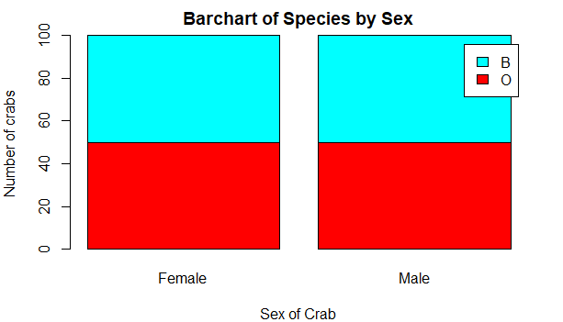

- The dataset is balanced across all groups. From the frequency table, there is equal crabs of the same sex and species. This is further backed by the graph as there is equal share of sex across the species.

Question 2
- R code
boxplot(BD~ sp+sex, data= crabs, main='Body Depth of Species by Sex', ylab = 'Body Depth', 'xlab = Species by Sex', col = rainbow(4))

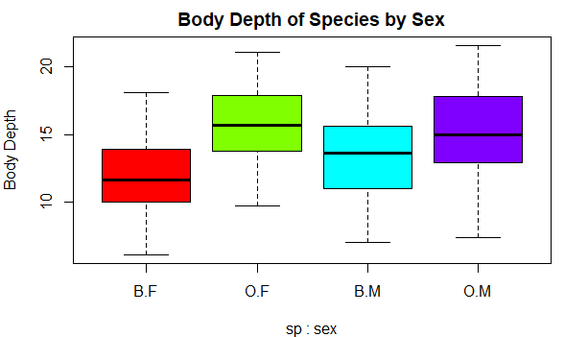
- Blue female crabs have the lowest body depth while orange male carbs have the highest body depth among the 4 groups. Female crabs have the lowest variability in their body depth while males have a higher variability of body depth. While all four groups have no outlier, orange males is skewed to the left meaning that there are a lot of crabs with high body depths.

Question 3
- R code
par(mfrow=c(1,2))
hist(crabs$CL[crabs$sp =='B'],main = 'CL_Blue', ylab ='Carapace length',xlab = 'Species', col = 'lightblue')
hist(crabs$CL[crabs$sp =='O'], main = 'CL_Orange', ylab ='Carapace length',xlab = 'Species', col = 'orange')
par(mfrow = c(1,1))

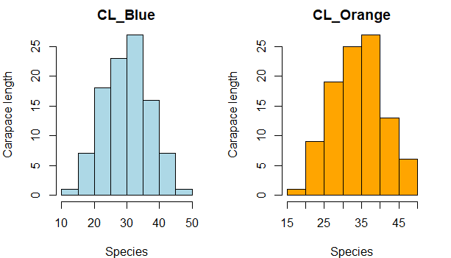
- From the above graph, both CL for blue and orange crabs has approximately a normal distribution. Blue crabs have a lower average carapace lenghth of about 30mm as compared to orange crabs which have an average carapace length of about 35mm
Question 4
- R codes
meansAll <- aggregate(crabs[, 4:8],
by = list(species = crabs$sp, sex = crabs$sex),
FUN = mean, na.rm = TRUE)
print(meansAll)

Output
species sex FL RW CL CW BD
1 B F 13.270 12.138 28.102 32.624 11.816
2 O F 17.594 14.836 34.618 39.036 15.632
3 B M 14.842 11.718 32.014 36.810 13.350
4 O M 16.626 12.262 33.688 37.188 15.324

- R codes

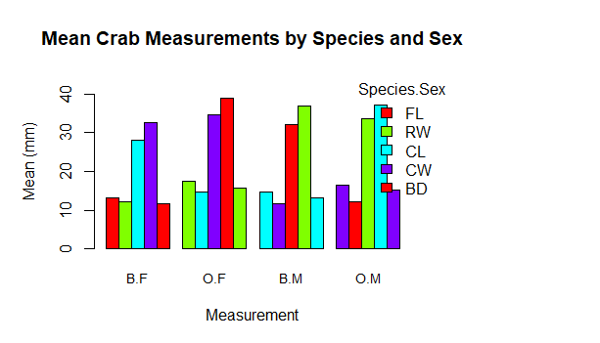
group_labels <- with(meansAll, paste(species, sex, sep = "."))
mat <- t(as.matrix(meansAll[, c("FL", "RW", "CL", "CW", "BD")]))
colnames(mat) <- group_labels
mat <- t(mat)
mat <- t(mat)
cols <- c(rainbow(4))
par(mar = c(5, 5, 4, 10))
bp <- barplot(mat,
beside = TRUE,
col = cols,
ylim = c(0, max(mat) * 1.15),
ylab = "Mean (mm)",
xlab = "Measurement",
main = "Mean Crab Measurements by Species and Sex",
names.arg = colnames(mat),
cex.names = 0.9)
legend("topright", inset = c(-0.12, 0),
legend = rownames(mat), fill = cols, bty = "n", title = "Species.Sex")

Question 6
The crabs dataset is a data frame with 200 observations. This data describes 5 morphological measurements on 50 crabs each of two colour forms and both sexes, of the species Leptograpsus and variegatus collected at Fremantle, W. Australia. The data contains 8 variables; species (factor with 2 levels), sex(factor with 2 levels), Index (integers), frontal lobe (mm), rear width(mm), carapace length (mm), carapace width (mm) and body depth (mm). The data set has equal females and males across the 2 species.
Blue female crabs have the lowest body depth while orange male carbs have the highest body depth among the 4 groups. Female crabs have the lowest variability in their body depth while males have a higher variability of body depth. While all four groups have no outlier, orange males is skewed to the left meaning that there are a lot of crabs with high body depths.
Both CL for blue and orange crabs has approximately a normal distribution. Blue crabs have a lower average carapace lenghth of about 30mm as compared to orange crabs which have an average carapace length of about 35mm.

